**As of 102518**

**Administrator Side**

1. [DONE] (No Delete) Edit and delete button are not functioning.
2. [DONE] Adding of roles is not working.
3. Add agency column sa pag-add ng users. Of course dapat may reference table si agency. I-attach ko yung list of agencies para maimport sa database. **list_of_nga_101418.xlsx**
4. [DONE] Error and Instruction menu should have System Name column.
5. [DONE] Attach the excel format for uploading sa **Import Data** menu. ***fissare_troubleshooting_library_format.xlsx***
6. Reports

Listings of Error/Issue and Solution Details (There should be a report where kita yung buong details ng system name,error, instructions and nakalist yung attachments na naka-attach sa kanya. ) –Should be printable. Cascade this also sa user side.

1. **Data Mining (SUPER PRIORITY)**

* I’ll send also the list ng websites na pwede kuhanan ng data. **websites for data mining.xlsx**
* Ang i-retrieve natin na data is kahit hindi na yung mga errors kasi mahirap mag-mine nun and of course need na ma-test before malagay sa system. Ang i-mine natin is yung mga documents, for example user’s manual, powerpoint presentations, etc.
* Of course bago dapat pumasok sa database dapat pipili si user kung sang system siya papasok. Bale may table then i-list lahat ng na-retrieve na data and all of that will be editable before saving sa database to make sure na relevant lahat ng data na makukuha.
* Ganito dapat magiging laman ng table. All fields are editable dapat.

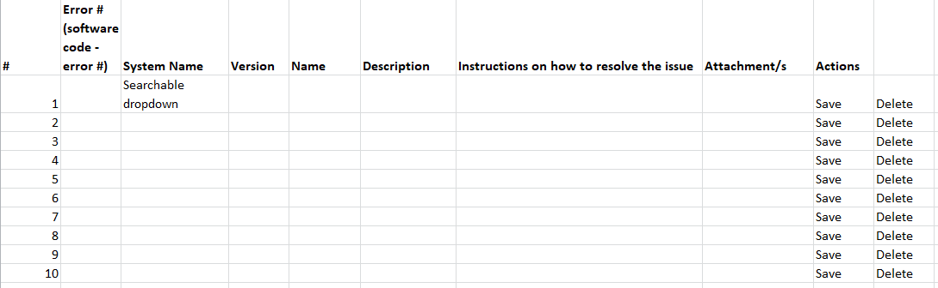

**User Side**

1. [DONE] Adding of supported system is not working as well as yung list ng systems.

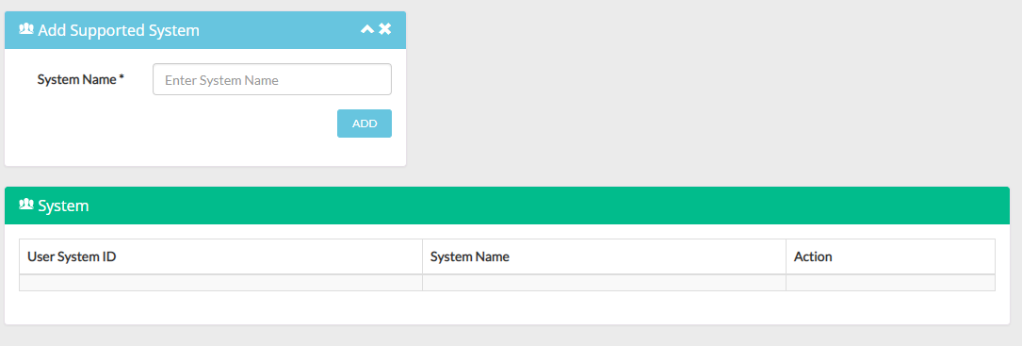

1. All reports added to the admin side should be seen also.
2. [DONE] List of errors on dashboard, Error and Instruction menu should have System Name column.
3. [DONE] Attach the excel format for uploading sa **Import Data** menu. ***fissare_troubleshooting_library_format.xlsx***

**Guest Side**

1. Searching.

* [DONE] Parang google nagstart ka palang magtype may suggestions na.
* Advanced search.

1. Security
   * Dapat kapag mag-download is manghihingi siya ng email. The file will be sent sa email and the file will have a password and the password will be sent along with the email.